VIETNAM GENERAL CONFEDERATION OF LABOUR
TON DUC THANG UNIVERSITY

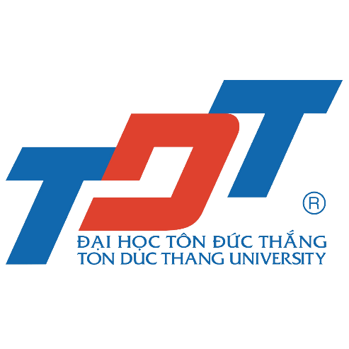

Master's Thesis Record

STUDENT’S INFOMATION

Full name:
Date of birth:
Student ID:
Major:
Thesis title:
Duration: from ________to ________

Advisor:

NOTE:

In order to improve the quality of master's thesis, Ton Duc Thang University publishes master’s thesis record form for all students when they start their thesis. Students should follow these guidelines:

- Thesis record is a note-paper to record the process of students’ thesis implementation:
- Record specific work with advisor: time, content, comments and confirmation. In case of exchanging via email or by other methods, it also need to be recorded (with the advisor’s confirmation).
b. This also record the work of students (including unexpected incidents) when going on field trips.
- Thesis records is an important proof of the master’s thesis implementation process. It is a prerequisite condition for student’s thesis submission before the Committee’s assessment of Master’s thesis.
- Students must follow this guidelines regarding TDTU’s regulation.

Date | Content | Confirmation of advisor

